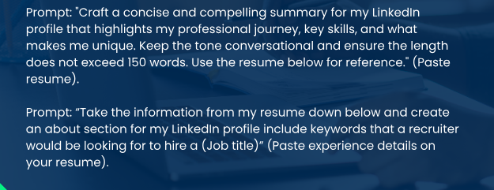

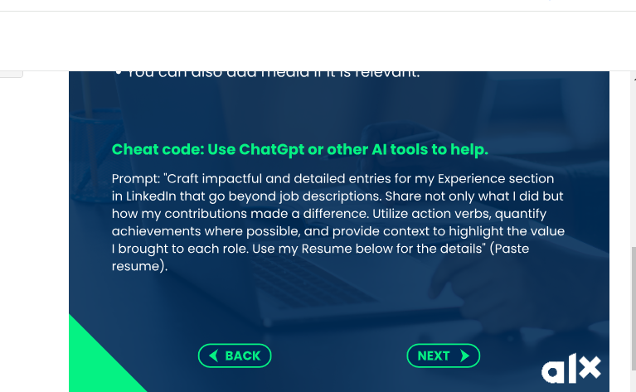

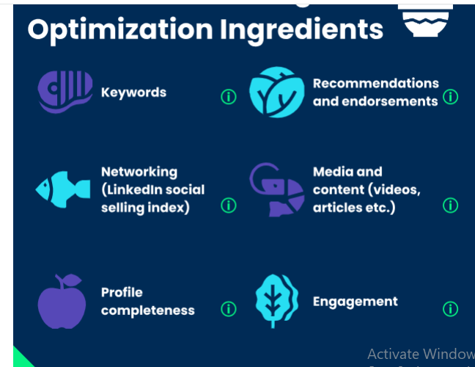

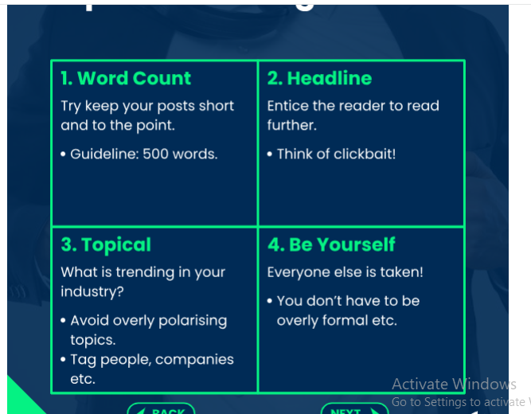



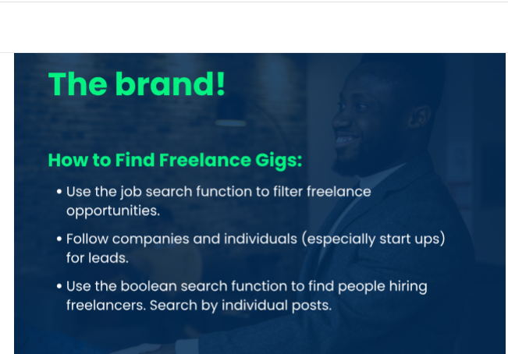

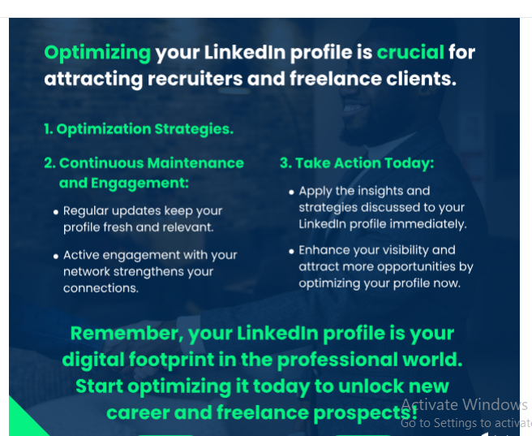

AI tools like [Careerflow](https://www.careerflow.ai/premium" \t "_blank) can help you improve your LinkedIn profile by giving you **personalized tips** on how to make it look better. This can be really useful whether you’re starting to look for jobs or just want to keep your profile up-to-date. It’s a simple way to make sure you’re showing your best side online.